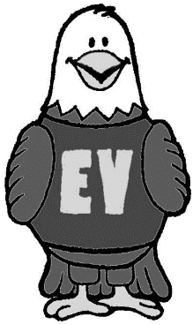
KINDERGARTEN SUPPLY LIST
2023-2024

Please do not label materials with your child’s name.
All materials will be shared.
- 1 Pair Foam Earpad Wired Headphones - 3.5mm plug
- 1 Backpack - large enough to hold a winter coat and an 11”x18” envelope
  - No rolling backpacks - we cannot accommodate them in our coat area
- 3 Crayola Crayons - 24ct
- 1 Crayola Washable Markers Broad Tip Classic - 10ct
- 3 Clorox Disinfecting Wipes - 35ct
- 4 Expo Dry Erase Marker, Low Odor, Ultra Fine Tip, Black
- 2 Boxes Kleenex Tissues - 125ct
- 1 Hand Sanitizer Clear Pump Bottle - 8oz
- 3 Dixon Ticonderoga HB #2 Pencil Pre-Sharpened - 12ct
- 1 School Scissors - 5" Blunt Tip
- 1 Box Ziploc Sandwich Bags - 125ct
- 1 Box Ziploc Freezer Bags Gallon - 38ct
- 12 Elmer's School Glue Stick Purple, Dry Clear (skinny ones for small hands)
- 1 Elmer's School Liquid Glue - 7 5/8oz
- 3 Plastic Two Pocket Folder w/ Prongs – Red, Green, Black
- Optional – One item from your teacher’s Kindergarten Classroom Wishlist
  - Ms. Hipol: https://www.amazon.com/hz/wishlist/ls/HFXX7WIT4GPL
  - Ms. Jackson: https://www.amazon.com/hz/wishlist/ls/1RBLOBGRXT92Q
  - Ms. Hansen: https://www.amazon.com/hz/wishlist/ls/2TGE1P0G38H51

